COLLECTION SHEET ENTRY TEST FOR Mifos
For Grameen Foundation,
October, 2009

Problem of Statement:
Testing Collection sheet entry details with mifos trunk and 1.3 tag version
The major concentration for the testing is to check the flowing issues:
1. Missing attendance:
2. Partial submits:
3. Duplicate Submits:
4. Missing Payments:
And also to find performance of the tag 1.3 and trunk versions.
Proposal:
Testing mifos trunk (revision 15849) and 1.3 tag version(revision 15757) with Load Runner to analyze the results and find the issues with mifos collection sheet entry.

Methodology:
-Create sample data for the collection sheet entry.
Sample Data can be created by running the following commands in Mysql prompt.

Open Mysql command prompt,

Use database:
Mysql>USE mifos_gazelle_acceptance;
Create the procedures:
1. Mysql>SOURCE < local path >/GF-CreateData.sql;
2. Mysql>SOURCE < local path >/GF-Customer_Script.sql;
3. Mysql>SOURCE < local path >/GF-Loan_Savings_Account_Script.sql;
4. Mysql>SOURCE < local path > /GF-LoanOffering_Script.sql;
5. Mysql>SOURCE < local path > /GF-Meeting_Script.sql;
6. Mysql>SOURCE < local path > /GF-Office_Script.sql;
7. Mysql>SOURCE < local path >/GF-Personnel_Script.sql;
8. Mysql>SOURCE < local path >/GF-Product_Script.sql;

Procedures can be created using Mysql tools like TOAD for Mysql

After creation of all the procedures,

Insert data
Mysql>CALL mifos_collectionsubmit_data_insert ();

-Parameterize the data in Load Runner to perform the tests.
-Run the tests, capture the images while the tests are being executed.
Findings:
Found JasperExceptions, NumberFormatExcetpions when collection sheet is filled and clicked “Preview” button.
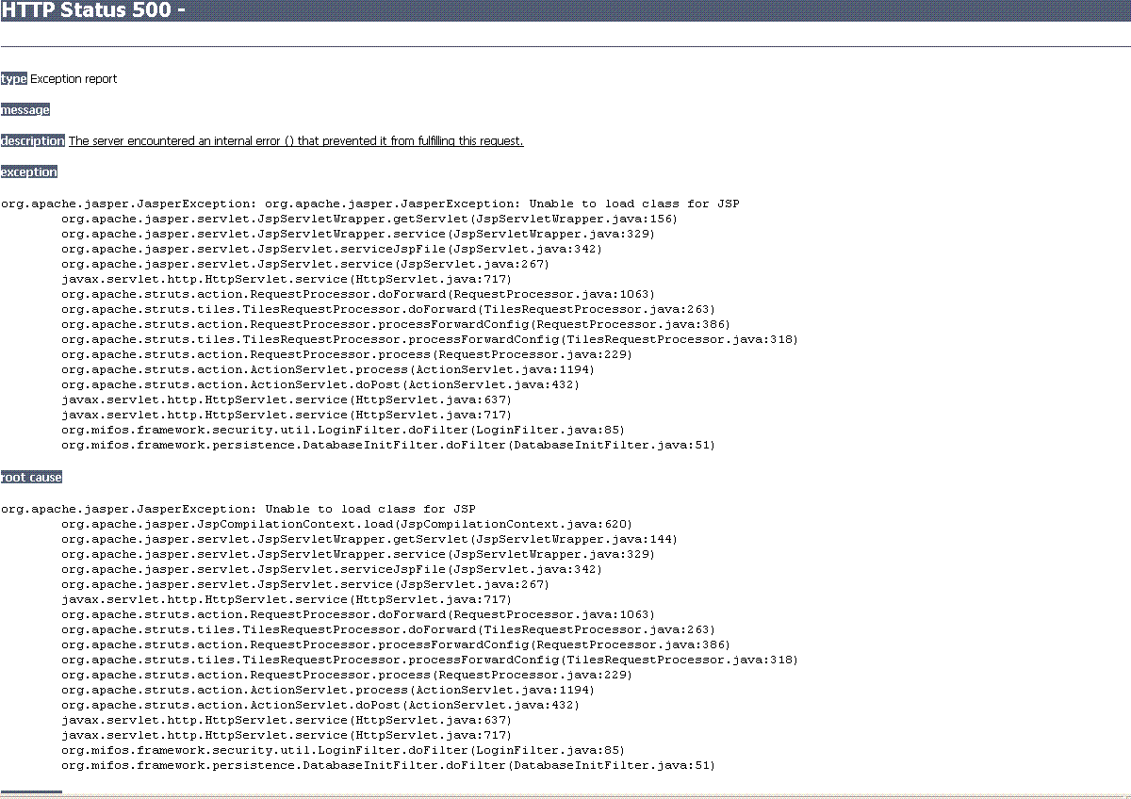

Data entered in the entry screen was not proper when it showed in the preview screen
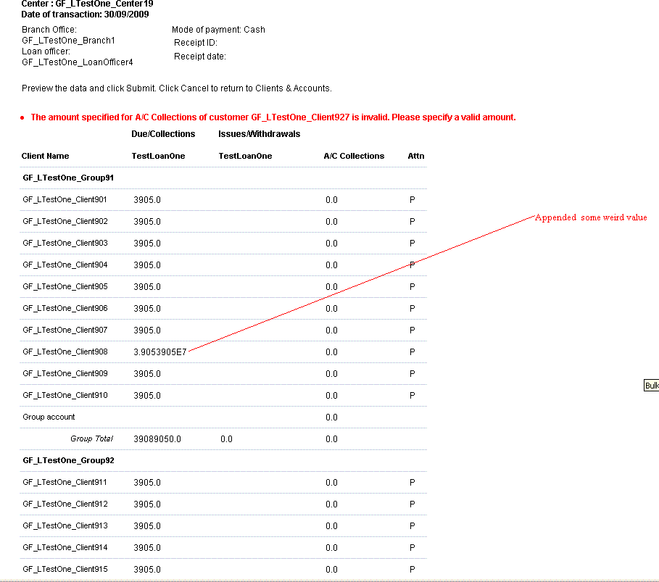

NumberFormatException:
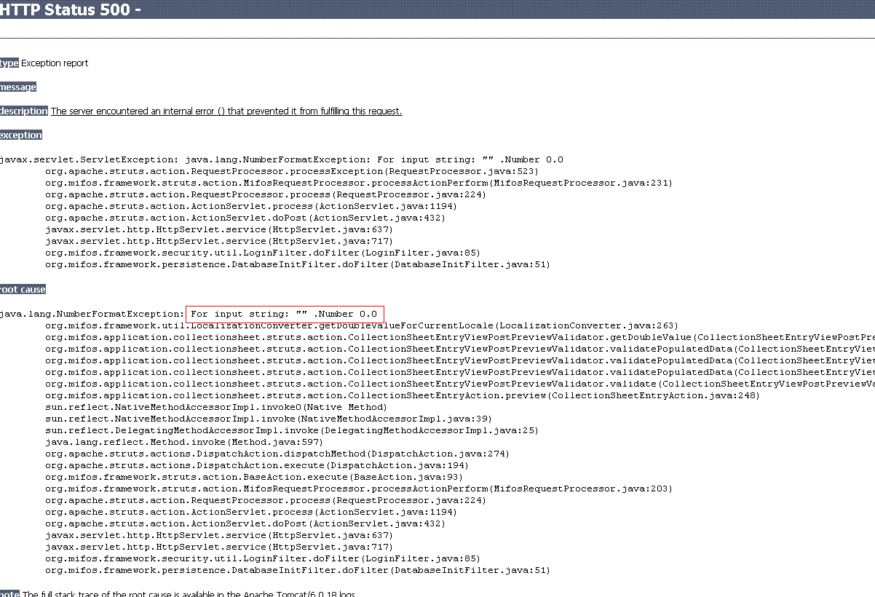

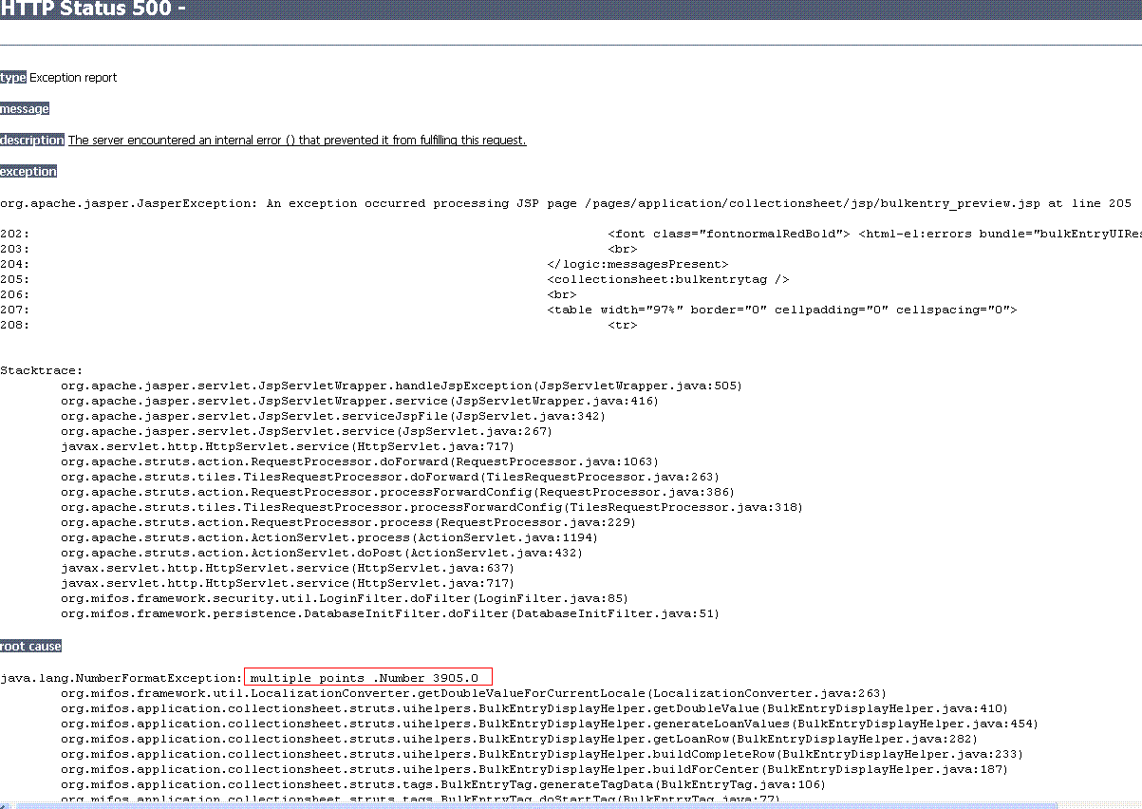
Because of the exceptions, there were missing attendance, partial submits and missing payments.
Query used to find Partial Submits:
select distinct(kc.global_cust_num), kc.display_name,o.display_name
from customer c,customer_meeting cm,recur_on_day rd,recurrence_detail cmd,
account a,loan_schedule ls,customer Gc, Customer Kc,office o
where c.customer_id=cm.customer_id
and cm.meeting_id=cmd.meeting_id
and cmd.details_id=rd.details_id
and c.parent_customer_id=Gc.customer_id
and Gc.parent_customer_id=Kc.customer_id
and a.customer_id=c.customer_id
and a.account_id=ls.account_id
and a.office_id=o.office_id
and a.office_id in (3)
and ls.action_Date=curdate()

Query used to find Missing Attendance:

Select Count(*),centercust.customer_id from customer
inner join customer groupcust on groupcust.customer_id = customer.parent_customer_id
inner join customer centercust on centercust.customer_id = groupcust.parent_customer_id
where customer.customer_id not in (select customer_id from customer_Attendance ) and customer.BRANCH_ID = 3 and customer.Discriminator = 'CLIENT' group by centercust.customer_id;

Query used to find missing payments:

Select Count(*),centercust.customer_id from customer
inner join customer groupcust on groupcust.customer_id = customer.parent_customer_id
inner join customer centercust on centercust.customer_id = groupcust.parent_customer_id
where customer.customer_id in (select customer_id from loan_schedule where payment_Status=0 and installment_id=1 ) and customer.BRANCH_ID = 3
and customer.Discriminator = 'CLIENT'
group by centercust.customer_id;

Query used to find Duplicate Submits:

select lad.account_id
from loan_activity_details lad,
(Select a.account_id,a.office_id as oid
from customer c, customer_meeting cm,recurrence_detail rd, recur_on_day rod,account a
Where c.customer_id = cm.customer_id
and cm.meeting_id=rd.meeting_id
and rd.details_id=rod.details_id
and a.customer_id=c.customer_id
and c.customer_level_id=1
and c.status_id=3
and rod.days=weekday(curdate())+2
and (a.account_state_id=5 or (a.account_state_id=6 and a.closed_date=curdate()))) dayacc
Where lad.account_id = dayacc.account_id
and lad.created_date=curdate()
and lad.comments='Payment rcvd.'
and lad.balan

Fixes:
Based on the screen shots, found that there are issues with CSE
- ‘LocalizationConverter’ class.
- PersistenceException: Could not find attendance for clientId 3 and meeting date Wed Oct 07 00:00:00 GMT+05:30 2009” this message is spurious error message that was in 1.3 tag.
Which have been fixed in the mifos trunk.
Performance:
Following information contains the performance of mifos tag 1.3 and trunk versions captured with LoadRunner.
Test Results for 50 Users, for mifos 1.3 tag with empty database:
Transaction Name | SLA Status | Minimum | Average | Maximum | Std. Deviation | 90 Percent | Pass | Fail | Stop
Action_Transaction |  | 60.132 | 191.292 | 315.386 | 62.101 | 268.729 | 220 | 80 | 0
Branch_Select |  | 0.021 | 2.132 | 25.947 | 4.238 | 7.676 | 300 | 0 | 0
Continue Click |  | 4.294 | 40.19 | 96.907 | 22.089 | 74.286 | 300 | 0 | 0
Enter Collection Sheet |  | 0.063 | 3.043 | 26.348 | 4.81 | 9.694 | 300 | 0 | 0
Kendra Select |  | 0.021 | 2.817 | 26.14 | 5.27 | 10.479 | 300 | 0 | 0
Loan Officer Select |  | 0.028 | 3.048 | 28.431 | 6.083 | 10.651 | 300 | 0 | 0
Login |  | 4.064 | 5.396 | 7.12 | 0.565 | 5.818 | 50 | 0 | 0
Logout |  | 11.024 | 11.5 | 16.497 | 0.961 | 12.473 | 50 | 0 | 0
Preview_Click |  | 0.064 | 3.117 | 24.246 | 5.018 | 10.55 | 258 | 42 | 0
Submit_Click |  | 6.767 | 104.121 | 190.833 | 40.62 | 156.72 | 220 | 38 | 0
vuser_end_Transaction |  | 11.024 | 11.5 | 16.497 | 0.961 | 12.473 | 50 | 0 | 0
vuser_init_Transaction |  | 10.219 | 11.006 | 12.781 | 0.457 | 11.452 | 50 | 0 | 0
Found all the issues except duplicate submits for the above test.

Test Results for 50 Users, for mifos trunk with empty database:
Transaction Name | SLA Status | Minimum | Average | Maximum | Std. Deviation | 90 Percent | Pass | Fail | Stop
Action_Transaction |  | 31.326 | 70.933 | 122.27 | 17.405 | 94.145 | 300 | 0 | 0
Branch_Select |  | 0.023 | 0.645 | 23.748 | 2.385 | 0.727 | 300 | 0 | 0
Continue Click |  | 0.207 | 3.363 | 27.152 | 3.461 | 7.127 | 300 | 0 | 0
Enter Collection Sheet |  | 0.043 | 1.898 | 33.137 | 5.612 | 4.075 | 300 | 0 | 0
Kendra Select |  | 0.021 | 0.717 | 23.48 | 2.984 | 0.776 | 300 | 0 | 0
Loan Officer Select |  | 0.021 | 0.454 | 20.8 | 1.789 | 0.657 | 300 | 0 | 0
Login |  | 1.28 | 2.325 | 3.829 | 0.651 | 3.033 | 50 | 0 | 0
Logout |  | 11.023 | 11.178 | 12.407 | 0.229 | 11.394 | 50 | 0 | 0
Preview_Click |  | 0.079 | 1.425 | 38.904 | 5.244 | 1.397 | 300 | 0 | 0
Submit_Click |  | 4.642 | 36.379 | 72.528 | 12.216 | 52.777 | 300 | 0 | 0
vuser_end_Transaction |  | 11.023 | 11.178 | 12.407 | 0.229 | 11.394 | 50 | 0 | 0
vuser_init_Transaction |  | 2.124 | 3.474 | 6.231 | 0.962 | 4.572 | 50 | 0 | 0
No errors/issues found for the above test. The response time of the submit_click transaction is gradually increasing as number of users increases.
Load Runner tests on trunk, the results are as follows:
For 20 users submit_click transaction was approximately 25 seconds
For 30 users submit_click transaction was approximately 35 seconds
For 50 users submit_click transaction was approximately 52 seconds

