Mifos Credit bureau Integration Initial Draft:
User story 1: Configuration:
- The admin user will be given the ability to add the supported credit bureaus and their products based on the country of selection.
- The credit bureaus configured in the above step will be made available to the organisation to be further mapped with loan products.
- To add a new credit bureau to the system, the admin user will have to navigate to adminThird party integrationCredit bureau integration

On clicking ‘credit bureau integration’ option the user will be taken to Credit Bureau summary page. The summary page displays the list of credit bureaus integrated with the Mifos instance. Initially the summary screen will not show the list as none of the credit bureaus would have been integrated. Later as and when the credit bureaus are added, the credit bureaus will be populated on this Credit bureau summary page. The Credit bureau summary page is as shown below:

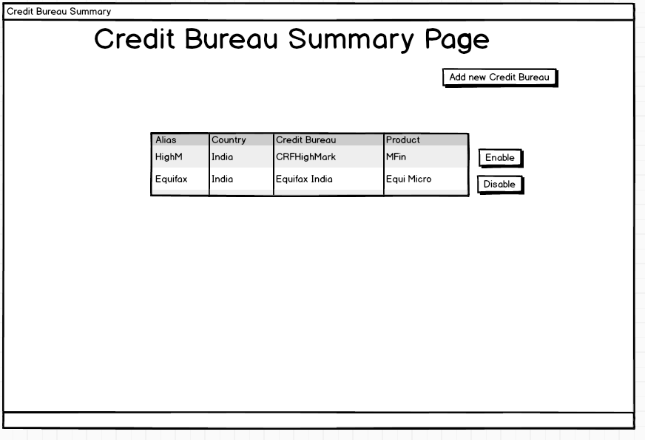

- Later when the admin user clicks on the ‘Add new Credit Bureau’ button on the credit bureau summary page, he will be redirected to the configuration screen, wherein he can configure the supported credit bureaus. The configuration page is as shown below:
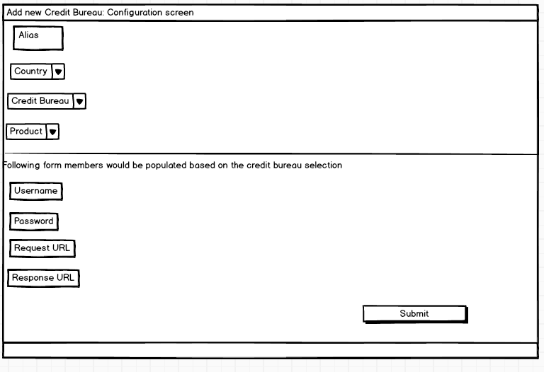

Configuration screen:

- After filling the details, the admin user will have to click on submit button to complete the addition of the credit bureau. Once the credit bureau is added, it would be displayed on the credit bureau summary page and the same will be available for the mapping with the loan products only when it is activated by pressing Activate button on the summary page.
- In case, the admin user wants to deactivate a credit bureau he can do so by clicking deactivate button on the credit bureau summary page. On clicking the deactivate button, the user will be asked from when he intends to deactivate the credit bureau. After the specified date the credit bureau which is scheduled to be deactivated will not be available for mapping with new loan products but the loan applications which are associated this credit bureau will remain unaffected and their loan applications can still be processed.

User Story 2: Mapping the Credit Bureau with the loan product:

- Once the credit bureaus are configured they would be populated in the new loan product creation wizard.
- The Loan officer will then be able to associate the credit bureau with a particular loan product by selecting the credit bureau which was configured by admin user.
- The loan officer will be given the choice whether to make the credit check mandatory or not for a particular loan product.
- If not made mandatory, the loan officer can process the loan application without any credit check.
- However, if credit check is made mandatory, the loan officer will have to make a credit check in order to process the loan application.
- In order to handle an event wherein the link between the Mifos and credit bureau is down and the credit check is mandatory for processing the loan application, an option would be given, whether a loan officer can skip the credit check and go ahead and process the application or wait for the link to be restored.
- Also the loan officer will have to set the duration for which the credit check report will be regarded as valid. The duration will be checked while disbursement of the loan. If the age of the report appears to be longer then set duration, the loan officer will not be able to process the loan disbursement.

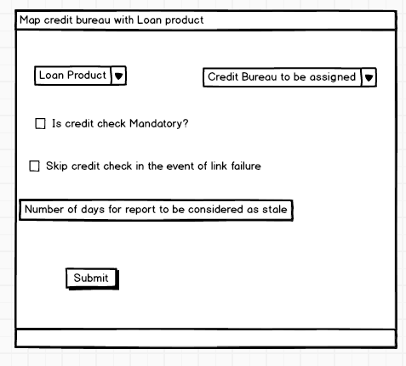

User story 3: (Credit check)
- When a loan officer opens the loan application for a particular product and if the credit check for that loan product is mandatory, then in that case credit check button is enabled and ‘Loan approve’ button and ‘loan reject’ button is disabled. Only when loan officer makes a credit check by pressing the credit check button and report is populated in the credit report tab at the bottom of loan application page, the Loan approve and Loan reject button is enabled.
- However, if the credit check for the loan product of the application is not mandatory, credit check button would be disabled and Loan Approve button and reject button would be enabled.
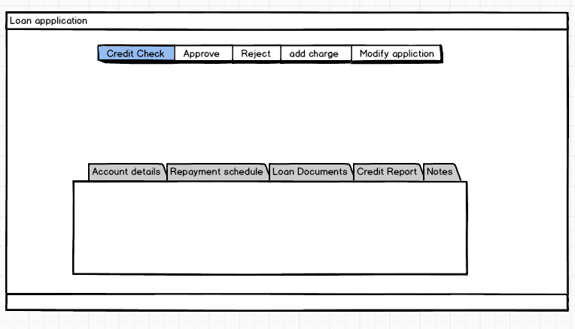
Timelines:
Timeline and implementation plan:

Currently the project has been split up into three modules being tracked as three sub tasks :
1) Configuration module: MIFOSX-2714 - Configuration Module for credit Bureau integration OPEN
In this module, the admin User will have the ability to map the credit bureaus with the loan products. This module will ask send request for credit check to credit bureau interface and would parse the display the response to Loan officers for theri ready reference.
Time line: 3 weeks and 2 days: 26 May - 17 June
2) Highmark Integration: MIFOSX-2716 - Highmark Integration OPEN
Integration of Highmark into Mifos. This module will provide infrastructure for request/response to and from highmark
Timeline: 2 weeks: 20 June - 1 July
3) Translation Module: MIFOSX-2717 - Translation module for credit bureaus OPEN
This module will work as an interface between the credit bureaus and Mifos. Basically it will parse the request and response to and from credit bureaus.
Timeline 2 weeks.
4) There would be two additional tasks besides above. One for report generation which will be cron job for data submission to credit bureaus and there would be one more credit bureau which will be added to Mifos.Both tasks would a total 3 weeks.

ETA for all the above tasks would be August 10. The deliverables would be as follows:
1) 2 credit Bureaus would be integrated.
2) Cron job for data submission to credit bureaus.
3)integration of credit check with loan application.

