WITHHOLDING TAX
Withholding tax is applied to interest. Whether tax is payable depends normally on the category of customer, and/or on the type of tax rate, the minimum taxable amount and/or the minimum amount of tax that is payable. At the time of capitalization, the tax which is deducted will be credited to the system account for withholding tax. This account is user defined as one of the compulsory GL accounts

TAX CONFIGURATIONS
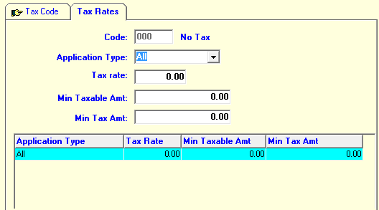

Brief Explanations

Tax rate
Enter the percentage of tax that should be deducted from the interest when interest is capitalized for an account.

Min Taxable Amt
In some countries no tax is payable if the amount of interest is below a certain amount. If so then enter this amount here.

Min Tax Amt
In some countries no tax is payable if the amount of tax would be below a certain amount. If so then enter this amount here

SAVINGS PRODUCT CONFIGURATIONS
- Interest on dormant - (Should be a check box)

Check this box if interest is payable on a dormant account of this product. If interest is not payable, the uncheck.
- No Interest on Holds - (Should be a check box)

Check this box if the balance amount on hold should be excluded from interest calculation. Interest will be calculated based on a new available balance after a balance hold is placed, edited, removed, or expired.

- Tax on interest- (Should be a check box)

If Withholding Tax is applied to interest payments, check this box, otherwise uncheck. The withholding tax will be applied as per the customer tax code, so that selected customers may still be tax exempt for this product, even when withholding tax applies. The taxes are defined in CFGR ´System Coding Schemes/Tax Rates´ section.

Surplus Payment Treatment

This refers to loan repayments that are received out-of-office and processed through a batch.

In certain organizations it sometimes happens that loan repayments are received in the field, often many at the same time, and often without having a properly up to date status of the loan account. As a result, sometimes more money is collected as repayment and then is needed to close the account. In such a case, we speak of a "surplus payment".

Normally, such so-called "field collections" are processed in a credit batch (or mixed batch). In the form below, you can specify what the system should do in case of a surplus payment being encountered in such a batch. You should select one of the options below:

Reject all surplus repayments

If encountered in the batch, all surplus repayments will be rejected in full and credited to the system error account instead. The accountant has to decide on a case-by-case basis what to do with the balances in the system error account. For example, the accountant can enquire how much is needed to close the loan and then split the total amount in the correct amount to close the loan and credit the excess part to a savings account of the same customer.

Credit linked account if existing, else reject

A loan account may have a so-called "linked" debit account (savings or current account). A linked debit account can be specified as the account to auto-recover the loan repayments from. This is then done at the time of opening of the account (note, that the availability of this is a product feature, see loan product generator). This account can also be used to post the excess payment to. This option is of course only relevant if you use the debit account facility.

Credit to linked account if existing, else to CSA

In this case, the system will first try to post to the linked debit account and, if that is not possible, to the CSA. The CSA is the Customer Surplus Account and this facility must also be activated through the product generator before one can specify a CSA at the time of opening of the loan. If neither the linked debit, nor the linked credit account (CSA) exists, the excess amount will go to the error account for manual processing.

Credit to CSA if existing (else reject)

If you select this, the system will try to post any excess payments to the CSA linked credit account. If the account doesn't exist, the excess amount will be posted to the system error account.

CHANGES TO LOAN PRODUCT SCREEN
Surplus Account – (Should be a check box)

Similarly to the recovery account, there can be a second linked account. This account can be used to post surplus repayment that may be collected in the field. A surplus repayment is a repayment larger than needed to close the loan account. If this happens, then you can specify that the "excess" payment should go to the surplus account. If you want to use the facility of surplus account, then you should check the checkbox for "Surplus Account".

