TELLER / CASHIER SAMPLE PROCEDURES
USE THE FOLLOWING TO CUSTOMIZE WRITTEN PROCEDURES FOR YOUR UNIQUE ORGANIZATION

Office Opening
The Office Manager or designated employee is responsible for opening and closing the branch on a daily basis and for assigning individual cashier stations. Cashiers much be ready to work by ENTER TIME.
Forms
Teller Cash Exchange Ticket
Procedure
- Prior to opening the doors to customers / members, verify:
  - The lobby is orderly.
  - Brochures and transaction forms are well stocked.
  - Under dual control, the vault is opened.
- Each individual cashier must obtain his or her cash drawer (or bag) from the vault. The daily working cash should not exceed (ENTER MAXIMUM CASH LIMIT HERE) at any time.
- If a cash order is placed, the funds will be obtained from the vault teller and verified before signing for the cash and placing it in the working drawer.
- Stock necessary supplies at the cashier station and be prepared to open to the customers (members) at the designated opening time.

Cash Drawer Maintenance
Cashiers / Tellers are assigned individual cash drawers that must not be used by another employee. The total amount of cash maintained in any one drawer may not exceed (ENTER CASH LIMIT HERE) on any given day. If cash needs exceed this limit, tellers must sell cash back to the vault at any time during the day.
Cashiers / Tellers must exercise judgment and care in handling cash. Discretion must be exercised to limit the amount of cash in view as well as discussions relating to cash. When a teller receives cash, he/she should verify the amount before placing it in the cash drawer. Rolled coin may be verified at the time it is used. Cash received or disbursed should be counted three times: once as the teller counts the cash out of the drawer, once as the teller counts by denomination on the calculator tape and once as it is disbursed to the member. Negotiated checks must be maintained in a locking cash drawer in transaction order.
Cash drawers must remain locked any time a teller is away from the window. Tellers are responsible for their keys.

Cash Handling/Counting
Cashier / tellers and others who handle cash have an important responsibility to safeguard the assets of the organization by counting, disbursing, and receiving cash accurately and safely. Cash is the organization’s most liquid asset and therefore is most susceptible to loss or misuse. For this reason, extreme care must be taken to safeguard the asset. Those employees who handle money must make this responsibility a priority.
Counting Cash
- Count from your hand to the counter.
- Never count loudly while receiving or disbursing cash.
- Count money starting with large denominations down to small denominations.
- When accepting cash from the customer / member, always count it in front of the customer / member the first time.
- Count coin starting with large denominations down to small denominations.
- Never put any cash received into the drawer until it has been verified.
- Concentrate while counting. Don’t try to talk and count at the same time.
- Don’t interrupt your count. Once you start to count, don’t let anything interrupt you.
- Be consistent in how you count out cash to customer / members. When counting back, key into the calculator the customer / member’s account number first then press the #sign. Count each denomination and enter into the calculator and total. Then count the total cash to the customer / member.
- Be consistent in the order in which you do things. For example: make a habit of giving cash back as the very last step in the transaction, after handling the deposit, answering questions, etc.
- If you are making change for a bill or exchanging several bills for other denominations, leave the original bill on the counter in your view until the transaction is complete. This way, the customer / member can’t say “I gave you a fifty” when it was actually another denomination. It’s in plain view.
- If a customer / member deposits an uncounted amount of cash, ask him/her to count it. If they do not want to take the time, get them to initial the deposit ticket to indicate he/she agrees with your count. Have the Branch Manager or Senior Customer / member Service Rep verify this cash before posting it to the customer / member’s account.
- When counting large amounts, pause slightly after each hundred.
- Put everything away after each transaction before starting the next one.

Excess Cash
Cashier / teller cash drawers are limited to no more than $20,000 ($30,000 on paydays) at any time. The cashier / tellers should attempt to end each day with as little cash as possible in their cash drawer. If the drawer limit is exceeded during the day, the excess cash should be sold to the vault during business hours to comply with the established guidelines. All cash sold to the vault must be banded in the appropriate dollar amounts.
Forms
Cashier / teller Exchange Ticket
Procedure
- Complete a cash order slip, listing denominations and total amount of cash being sold back to the vault.
- Make the following entry in the Mifos system (DBH – NOTE INSERT TELLER CASH PROCEDURE HERE)
- Submit the completed form to the Senior Customer / member Service Rep who will accept the form and the cash being returned.
- The Senior Customer / member Service Rep will verify the amount of cash received and, under dual control, will place the currency in the vault and make the appropriate entry under the vault cashier / teller number. (DBH – NOTE INSERT TELLER CASH PROCEDURE HERE)
- One copy of the cashier / teller exchange ticket stays with the cashier / teller’s daily work. The second copy stays with the Senior Customer / member Service Rep.

Deposits
Customer / members may make deposits to their accounts in person, via mobile money (LIST ALL WAYS A DEPOSIT MAY BE MADE). The customer / member must provide their account number and deposit instructions. Checks received for deposit are subject to the Check Hold Policy. Cash back is permitted on deposits and must be signed for by the customer / member.
Forms
Transaction Receipt
Procedure
- Verbally review the transaction request provided by the customer / member to ensure the instructions are understood.
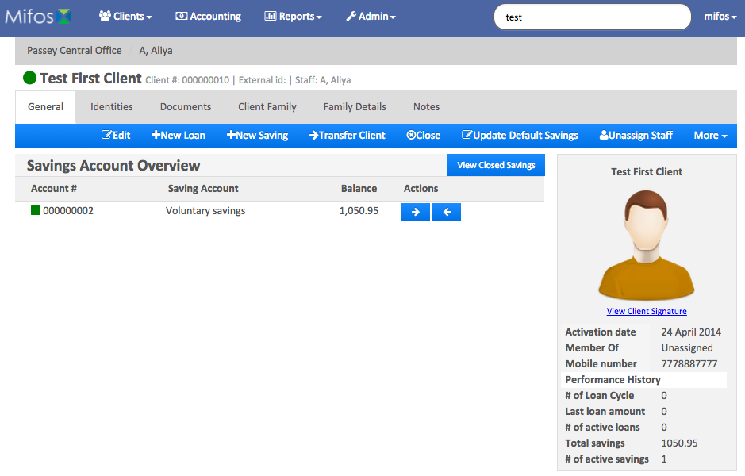
- Look up the account by name or ID number by entering it into the Mifos search bar. If there are multiple entries, click on the desired account.
- Verify the information on screen matches the information provided by the customer.
- Accept funds and place them in a safe area while processing the transaction. Do not place funds in the cashier / teller drawer at this time.
- Click on the account for the deposit. You will see a blue action bar to make deposit, withdrawal, calculate interest and more. Select, ➔Deposit.
- Verify the amount requested for deposit matches the funds accepted.
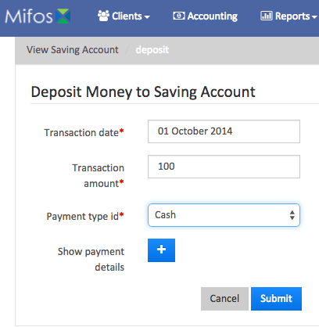
- (IF CHEQUES ARE ACCEPTED) Examine all checks presented for: payee, proper date, written amount agrees with numeric amount, signature, routing and transit number, necessary endorsements and if subject to checks holds. --Stamp the back of all checks with the organization endorsement stamp. Write the customer / member's account number and suffix on the back of the check within the top 1½" allotted space.
- Enter the transaction date. This will usually be today’s date, however, the system does allow a transaction to be backdated if necessary.
- Enter the transaction amount.
- Enter the payment type – Cash, check, (ENTER THE PAYMENT TYPES ACCEPTED BY YOUR ORGANIZATION).
- Additional details are available (IF YOUR ORGANIZATION USES ADDITIONAL DETAILS, COMPLETE THE INSTRUCTIONS FOR ACOUNT#, CHEQUE#, ROUTING CODE, RECEIPT # AND BANK#
- Place cash and cheque in the cash drawer.
- Review the information entered on the screen, and if correct, click Submit.
- Provide the customer / member a receipt and place the other copy slip in the designated area for balancing at the end of day.
Withdrawals
Customer / members may withdraw funds in the form of check or cash, Customer / members requesting withdrawals must present a valid photo ID with a signature. The identification requirement may be waived if the customer / member is well known by the cashier / teller. Joint owners may also withdraw funds after presenting proper identification
Forms
Transaction Receipt
Procedure
- Verbally review the transaction request provided by the customer / member to ensure the instructions are understood.
- Verify the customer / member's identification. Enter the customer / member's account number and cross-verify to the customer / member's name. Also compare the photograph in the system with the person standing before you.
- Verify the amount requested is available for withdrawal.
- Verify that there is no loan past due amount due.
- Click on the account for the withdrawal. You will see a blue action bar to make, deposit, withdraw, calculate interest and more. Select, ➔Withdraw
- Enter the transaction date. This will usually be today’s date, however, the system does allow a transaction to be backdated if necessary.
- Enter the transaction amount.
- Enter the payment type – Cash, check, (ENTER THE PAYMENT TYPES ACCEPTED BY YOUR ORGANIZATION).
- Additional details are available (IF YOUR ORGANIZATION USES ADDITIONAL DETAILS, COMPLETE THE INSTRUCTIONS FOR ACOUNT#, CHEQUE#, ROUTING CODE, RECEIPT # AND BANK#
- Following cash handling procedures, give the customer / member the cash requested.
- Give the customer / member a copy of the receipt. Place the other copy in the designated location for balancing at the end of day.

Loan Payments/Payoffs
Customer / members may make loan payments over the counter, by regular account transfer or mobile money. (LIST THE METHOD OF PAYMENT AVAILABLE IN YOUR ORGANIZATION). Loans may be paid ahead with no penalty (VERIFY THIS FOR YOUR ORGANIZATION). If a loan payment is received for more than the amount due, check to see if the customer / member is wishing to pay more than one loan. If not, post the full amount to the loan, unless the customer / member has provided specific instructions to the contrary. If a significant difference exists, call the customer / member to request instructions. If the customer / member cannot be contacted, post the full amount to the loan and make a note in the on line account comment area.
If a loan payment is late, post the payment as usual, unless the account is flagged by Collections. If this is the case, contact Collections immediately for instructions.
Forms
Transaction Receipt
Procedure
- Verbally review the completed transaction with the customer / member to ensure the instructions are understood.
- Accept the funds and place them in a safe area while processing the transaction. Do not place funds in the cashier / teller drawer until the transaction is posted to the system.
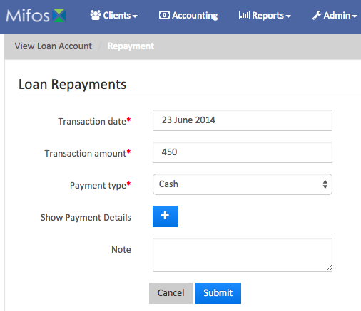
- (IF YOUR ORGANIZATION ACCEPTS CHECKS) Examine all checks presented for: payee, proper date, written amount agrees with numeric amount, signature, routing and transit number, necessary endorsements and if subject to checks holds. Stamp the back of all checks with the organization endorsement stamp. Write the customer / member's account number and suffix on the back of the check within the top 1½" allotted space.
- Verify the customer / member's identification. Enter the customer / member's account number and cross-verify to the customer / member's name. Also compare the photograph in the system with the person standing before you.
- Select the loan account to be paid from the list on the screen. The loan detail page will appear. In the blue navigation bar, you will see Add loan Charge, Prepay Loan, Make Repayment, Undo Disbursal and More. Select $Make Repayment.
- Verify the Transaction date. Enter the correct date as necessary.
- Enter the Transaction Amount
- Use the drop down options to select the Payment Type.
- If your organization uses the Show Payment Details, enter the listed information.
- Enter a note in the system if required.
- Review the on screen information, if correct, press Submit.
- Give the customer / member receipt.

Transfers
Customer / members may transfer funds from any account in which they are an owner to any other account within the organization. Transfers may be requested in person, in writing, via mobile.
Forms
Receipt
Procedure
- Verbally review the transaction request with the customer / member to ensure the instructions are understood.
- Complete the transfer request according to the customer / member's instructions. Have the customer / member sign the transaction slip.
- Give the customer / member a copy of the transaction receipts. Only give the customer / member receipts for accounts on which they are an owner or joint owner, or place the receipt in a sealed envelope.
- Place the documents in the designated area for balancing at the end of day.

Check Cashing
WHFCU will cash checks for customer / members only. Checks must be made payable to the customer / member. Third-party checks are not normally accepted. Consult a supervisor before accepting a third-party check.
Non-customer / members presenting a customer / member's check (share draft) may cash the check with proper ID.
On a case-by-case basis, we may cash a check for non-customer / members as a courtesy. This may include a visitor to the complex with a local check payable or endorsed to the customer / member sponsor. In such cases, Customer / member Service representatives must obtain approval from the Branch Manager.
Procedure
Accept check(s) for which cash has been requested from the customer / member.
Determine whether the check can be cashed or must be deposited. Verify that the account is in good standing.
Examine all checks presented for: payee, proper date, written amount agrees with numeric amount, signature, routing and transit number, necessary endorsements and if subject to checks holds. If the check is drawn on other than a U.S. bank, forward it to the Head Cashier / teller for collection. No cash or credit will be given to the customer / member until the check is collected. Stamp the back of all checks with the organization endorsement stamp. Write the customer / member's account number and suffix on the back of the check within the top 1½" allotted space. Stamp with cashier / teller stamp.
Verify the customer / member's identification. If the individual is a non-customer / member cashing a customer / member's share draft, write the ID number and expiration date on the front of the check.
Post the transaction to the system. If the check is drawn on WHFCU, enter the check number into the system, clear the check and stamp the back of the check.
Disburse the funds to the customer / member and verify the total against the transaction receipt and calculator tape.
Place the check and transaction slip in the designated location for balancing at the end of day.

Mutilated Money
Currency will be received from customer / members, which is considered mutilated. As these funds are received, they are to be sold to the vault. The Senior Customer / member Service Rep. will accumulate these funds and return them with excess coin to the Federal Reserve.
Forms
Cashier / teller Cash Exchange Ticket
Procedure
Upon receipt of mutilated currency, complete a Cashier / teller Cash Exchange Ticket.
Follow the excess cash procedures to sell money back to the vault.
The Senior Customer / member Service Rep. will sell the mutilated funds from the vault to the Federal Reserve.

Cashier / Teller Balancing
Each cashier / teller must verify that the system transaction totals and cash on hand are in balance at the end of each day. Excessive differences will be grounds for disciplinary action, up to and including dismissal.
Procedure
Run one tape on all checks received and verify the number of checks and the dollar amount to the system.
Count all cash and coin in the cash drawer and verify the totals against the system totals.
Once you determine your checks and your cash are in balance, microfilm your checks in preparation for delivery to the Courier Service.
Run a tape on all traveler‘s checks and money orders sold and verify the total to the system totals.
If in balance, place the daily work in the designated area. If not in balance, count cash and run tapes again. If an out-of-balance situation remains, contact the Branch Manager immediately for instructions.
After the individual work is balanced and filmed, assist with any necessary office closing work that is outstanding. This may include assisting a cashier / teller find an out of balance situation, filming daily work and check deposits to FED Reserve, balancing MO & Traveler’s checks sold or putting supplies away.

Error Corrections
A transaction incorrectly keyed into a customer / member’s account must be corrected.
Same Day Error Corrections
If the error is discovered on the same day it occurs, a VOID transaction code can be performed on the customer / member's account. It provides the ability to reverse a transaction that was posted on the same day.
To VOID a transaction, input the customer / members account number. In the transaction area, type VO. A screen will appear showing transactions done on the account. Highlight the transaction to be voided, and follow the on-screen directions. Transfers and ON US drafts have two transactions to be voided. If both sides of the transactions are not voided, an out of balance condition will occur. Once the transaction is voided, input it correctly
Previous Day Error Corrections
Refer to Symitar Online Publications for instructions on these corrections. There are two ways to do previous day corrections.
Double click the SFW Online Publications Icon on your desktop. Click on the Search tab. Type in the word adjustment. The 1st title will be Adjustment Z. Double click in the highlighted area and follow the instructions that will come up.
The second method of correction is Recast. Type in recast. You will have two selections. RL is used to recast a loan. RS is used to recast a share account.
Cash Over and Short.
Ideally, all cashier / tellers should balance to the penny on a daily basis. This, however, is not always possible. If the difference is in excess of $10 the cash difference checklist is to be completed and a copy submitted to the Branch Manager if the difference is not found. If a difference is in excess of $100 and not found, a copy of the cash difference checklist must be forwarded to the CEO.
Forms
Cash Difference Checklist
Procedure
When a cashier / teller is out of balance, first verify the cash in drawer and review the check calculator tape to ensure that those figures are correct.
If the error is not found, obtain a copy of the Cash Difference Checklist. Go through all the steps listed on the checklist to find the error.
If the cashier / teller is still out of balance, post the proper adjustment to the system. Inform the Branch Manager.
If the difference is more than $100, forward a copy of the checklist to the CEO.
If a pattern is established for a recurring error, plan a training program and other appropriate action to rectify the situation.
File the copy in the designated area.

CASH DIFFERENCE CHECKLIST
Cashier / teller Name: | Number: | Date:
Amount of Difference: $
 | CHECKED BY | RECHECKED BY
1. Establish exact amount of difference: Over or short.
2. Verify all cash turn-in & buy tickets to ascertain that all items are properly debited or credited.
3. Fine count strapped, mutilated, and bait currency, and bulk coin in drawer.
4. Re-run checks received and verify total to cashier / teller sheet and system totals.
5. Examine cash breakdown for all transactions.
6. Check addition on deposit and withdrawal receipts and all notations made including bill denominations.
7. Compare check run to deposit receipts.
8. Verify whether another cashier / teller has an offsetting difference or one of a similar amount.
9. Verify transfers of funds from one account to another.
10. Verify money order transactions to system totals and receipt of funds for payment.
13. Check any other miscellaneous receipts and disbursements.
14. Check for missing documents under cashier / teller machines and in garbage.
15. Bag & retain cashier / teller area garbage until difference is found.
Check (√) and complete all that apply:
 Difference found and corrected on______________ (date) by ________________________ (sigstandarenature).
 Copy of Cash Difference Checklist to the Manager on ______________ (date) by _______________________ (signature) if difference is [ENTER AMOUNT HERE] or more and not found.

